- The jump in UK CPI inflation in October reflected Ofgem's higher energy price cap and the unwinding of a large base effect in September's outturn. We think inflation will rise in the near-term as further base effects come into play. In particular, core goods inflation should climb higher from next month, then from next spring the drag from energy should cease.
- Policy measures announced in last month's Budget and the likelihood of a stronger dollar after the US election result mean we have raised our 2025 CPI inflation forecast to 2.8%, from 2.5% last month.
CPI inflation rose to 2.3% in October, from 1.7% in September. The upturn reflected two key drivers. First, there was a much smaller drag from the energy category, as Ofgem's 9.5% hike in the energy price cap took effect. Second, a large base effect that weighed on core inflation in September unwound. These upward pressures were partly offset by a bigger drag from fuel – pump prices fell by 2% m/m between September and October, versus a 1.7% m/m rise between those months last year. Elsewhere, RPI and RPIX inflation climbed to 3.4% and 2.8% respectively in October, from 2.7% and 2% in September.
Base effects will play a major role in pushing up CPI inflation over the next six months. In particular, base effects caused by a series of weak outturns for core goods prices last winter should push up core inflation from next month. Similarly, the drag from the energy category should disappear entirely from the spring.
Two recent events suggest inflation is likely to be stronger next year than we had previously projected. We have raised our forecast for services inflation in 2025 in response to the Budget, with VAT to be imposed on private school fees from January and firms expected to pass on some of the impact of the increase in employers' national insurance contributions into prices. We also expect Donald Trump's victory in the US election to result in a stronger US dollar, as looser US fiscal policy means fewer interest rate cuts from the Federal Reserve. A weaker pound will mean higher inflation for imported goods. As a result, we now expect CPI inflation to average 2.8% in 2025, 0.3ppts higher than in last month's forecast.
Chart 1: We have raised our 2025 CPI inflation forecast to 2.8%
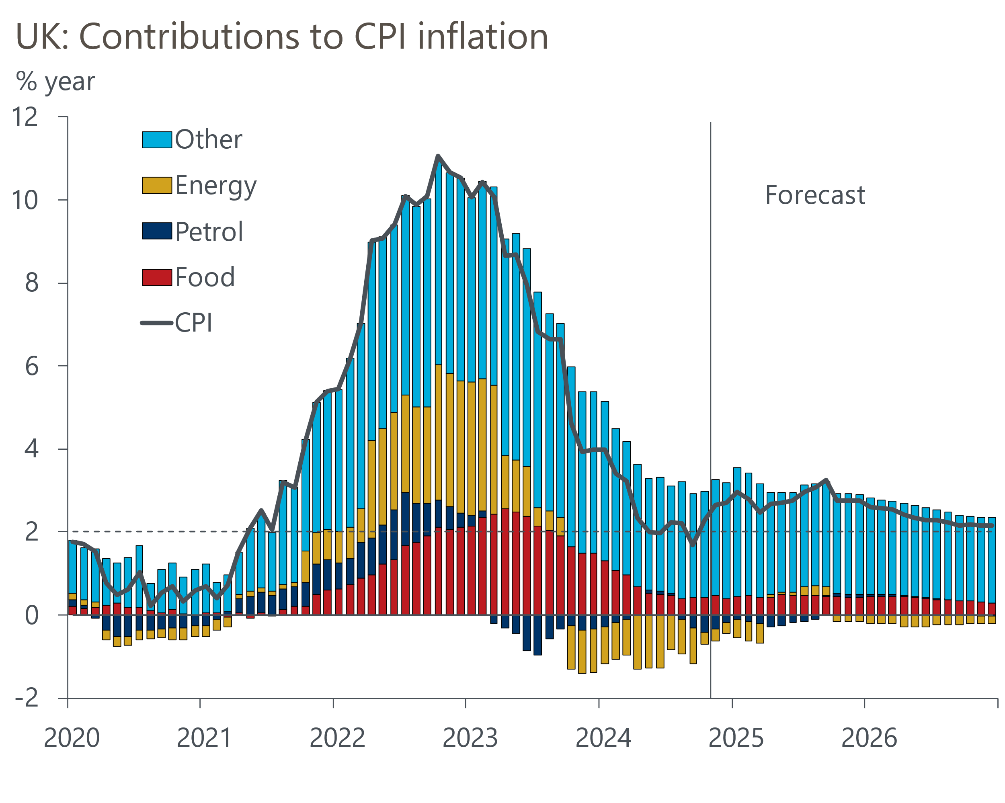
Source: Oxford Economics, Haver Analytics

